Thesis formatting and preparation guidelines for Graduate students

UNIVERSITI TEKNOLOGI BRUNEI

Table of Contents
Chapter 1: Introduction 1
1.1 How to Use this Template 1
1.2 Cross-References 1
Chapter 2: Formatting Guidelines 2
2.1 Style Guide and Instructions for Thesis 2
2.1.1 Reasons for Regulations 2
2.1.2 Responsibilities 2
2.1.3 Size of the Thesis 2
2.1.4 Paper 3
2.1.5 Font Styles and Paragraphs 3
2.1.6 Margins 3
2.1.7 Spacing 3
2.1.8 Pagination 3
2.1.9 Cover Page 4
2.1.10 Pre Main Body 4
2.1.11 Thesis Main Body 4
2.1.12 Abstract 5
2.1.13 Declaration 5
2.1.14 Publications 5
2.1.15 Chapter 1: Introduction 5
2.1.16 Chapter 2: Literature Review 5
2.1.17 Chapter 3: Methodology 6
2.1.18 Chapter 4: Results and Discussion 6
2.1.19 Chapter 5: Conclusions and Recommendations 6
2.1.20 Figures 6
2.1.21 Tables 7
2.1.22 Equations 8
2.1.23 Footnotes 9
2.1.24 Appendices 9
2.1.25 References 9
2.1.26 Plagiarism 10
References 11

: Introduction
This document outlines the formatting requirements for preparing the graduate studies theses including MSc by Coursework, MSc by research and PhD. Thesis template is also provided which is based on the information in this document. Please read the entire document and use it to prepare the thesis.
Students who use LaTex should comply as much as possible with the guidelines in preparing their theses.

How to Use this Template
The MS Word allows you to define styles. For example, this text is “Body Text”. The chapter heading is Heading 1 and the subsections are Heading 2 and Heading 3. Do not use more than level 3 Heading (for example 1.2.1.1 is not allowed). The thesis template follows a specific style which students may use.

Cross-References
Word allows you to automatically generate the Table of Contents and List of Figures/Tables via the “Insert Reference Index and Table” function. If you use the styles properly for each heading and captions this tool will save a large amount of time.

: Formatting Guidelines

Style Guide and Instructions for Thesis
This document provides the MSc degree students the guidelines to prepare the thesis. Students must adhere to the guidelines in order to maintain a standard and consistent formatting for all student theses. Penalties maybe imposed by Programme Area if the thesis does not conform to the specified formatting.

Reasons for Regulations
The guidelines given in this document are not arbitrary but necessary. Papers and margins must be uniform to allow for binding and trimming.

Responsibilities
Students are responsible for the accurate preparation of copies, including formatting, printing or typing, etc. Students should not expect their supervisors to copy-read or proofread their theses for spelling, grammar, and formatting errors, nor should they expect them to correct or edit the copies. They must pay careful attention to prepare their theses error free. Furthermore, the final version of the thesis maybe checked by the project coordinator. Students whose theses fail to adhere with the specified formatting maybe penalized.

Size of the Thesis
The thesis should be printed in English, in the third person writing. The length of the thesis for different graduate degree levels are suggested as follows:
Degree level | Thesis maximum words limit | Approximate page count
MSc by Coursework | 15,000 | 50
MSc by Research | 40,000 | 130
MPhil | 60,000 | 190
PhD | 80,000 | 255

The numbers in the table excludes appendices, footnotes and bibliographies.

Paper
A4 size bond paper of at least 80 grams should be used.

Font Styles and Paragraphs
The font size 12 and style Times New Roman must be used for normal text throughout the thesis including the sections before the Introduction Chapter. The main exception is the text contents in the tables for which font size 11 and style Times New Roman is used. The text style used in figures is Times New Roman or Arial size 11.
Furthermore, different font sizes are only used for chapters, sections and subsections headings. The text color throughout the thesis is Black and must remain the same.
Indentation of paragraph lines is not allowed. Avoid using excessively long paragraphs. Utilize the space of each page of the thesis efficiently to leave large empty spaces (gaps) at the bottom of pages.

Margins
On the top, bottom and right-hand side margins of the page is to 20 mm and the left-hand side margin is set to 40 mm.

Spacing
The 1.5 spacing is used throughout, except for abstract which uses single spacing

Pagination
Every page in the thesis must be assigned a page number except the cover page. Use lower case Roman numerals.
Use Arabic numerals at the bottom center of the paper starting from the first chapter. Numbering must run consecutively with no missing numbers, and the use of 12a, 12b, etc. is not permitted. Arabic numerals are used beginning with the first page of first Chapter with number 1.

Cover Page
The cover should have the following format:
- UTB logo
- Title of the thesis
- Author’s name
- “Submitted in partial fulfillment...” (MSc by coursework) and “Submitted in fulfillment...” (MSc by research and PhD) element
- University name
- Date of submission

Pre Main Body
The following are suggested for the pre main body of thesis structure:
- Abstract
- Declaration Page
- Publications
- Acknowledgements
- Table of Contents, including page numbers
- List of Figures
- List of Tables
- List of Notations and Symbols

Thesis Main Body
The main body structure of thesis normally includes the following structure for MSc by coursework thesis:
- Chapter 1: Introduction
- Chapter 2: Literature Review
- Chapter 3: Methodology
- Chapter 4: Results and Discussions
- Chapter 5: Conclusions and Recommendations
The main body structure of thesis for research students (MSc and PhD) should include Introduction and Literature Review as the first two chapters. The remaining chapters can be flexible and formulated upon the agreement with research supervisor.

Abstract
This section should normally not extend beyond a single A4 side, and to facilitate this, single spaced typing is permitted for the summary only. Abstracts should be no longer than 300 words long. It should describe the problem or topic, any important or distinctive methods used in the research, and the principal conclusions reached. It should not include references, equations, figures and tables.

Declaration
The declaration page should follow the cover page. Example is given in the template document.

Publications
The conference and journals articles should be listed on this page. If there is no publications, this page can be removed.

Chapter 1: Introduction
This chapter normally includes the Problem Statement (identify the problem(s) that the research project wants to address, magnitude, relationship and question(s) the project wants to answer or solve). The chapter also includes the Objectives, as well as some general background information on the previous work in the subject area (referenced).

Chapter 2: Literature Review
The literature review is a written overview of major writings and other sources on a selected topic. Sources covered in the review may include scholarly journal and conference articles, books, government reports, Web sites, etc. The literature review provides a description, summary and evaluation of each source. It is usually presented as a distinct section of a graduate thesis.

Chapter 3: Methodology
This chapter provides the method(s) to execute the project work. For example:-
- Observation
- Design and/or system development
- Investigation on material/ component selection
- Experimental setup and procedures
- The working process and implementation
- Simulations and tests
- Engineering concepts, etc.
The chapter also intends the reader to understand the systematic investigation that was done by the developer.
- How the investigation was conducted to establish facts
- Where was the data collected from
Making detail drawings for the selected design with all dimensions, materials used and manufacturing instructions according to the parametric design calculations (if applicable)

Chapter 4: Results and Discussion
This chapter includes the results, discussion and analysis (chapter headings and sub-headings must be meaningful and must correspond to the content).

Chapter 5: Conclusions and Recommendations
It should include the information to meet the aim/objectives. Based on the research finding the student can recommend the further development.

Figures
All figures, (computer graphics, photographs, color maps, color illustrations, drawings, charts, graphs, etc.) must be neat having good quality. All such materials must fit inside the regular margins of the page. Oversize materials should be reduced in size to conform to the margins. The text style used in figures is Times New Roman or Arial size 11.
Each illustration should be labeled as “Figure X.Y.” consecutively through the thesis where X is the Chapter number and Y is Figure number (For example Figure 3.1. refers to the first figure in chapter 3). If more than a few figures are used, a List of Figures should follow the Table of Contents.
All figures must have captions. All figure captions must be located below the figure and both figure and caption must not be split between pages. The figure caption and label used in Figure 2.1 can be copy/pasted and used for additional figures by changing the label number and caption text.
The list of figures will be automatically updated. Use 300×300 resolution for figures in order to avoid having a large size document. References should be specified to figures taken from other resources within the figure caption.
Do not refer to figures in the main text as “see below” or “see above”. Refer to all figures using their numbers. For example “As shown in Figure 3.2 …”. Reference to figures should be included within the main text.
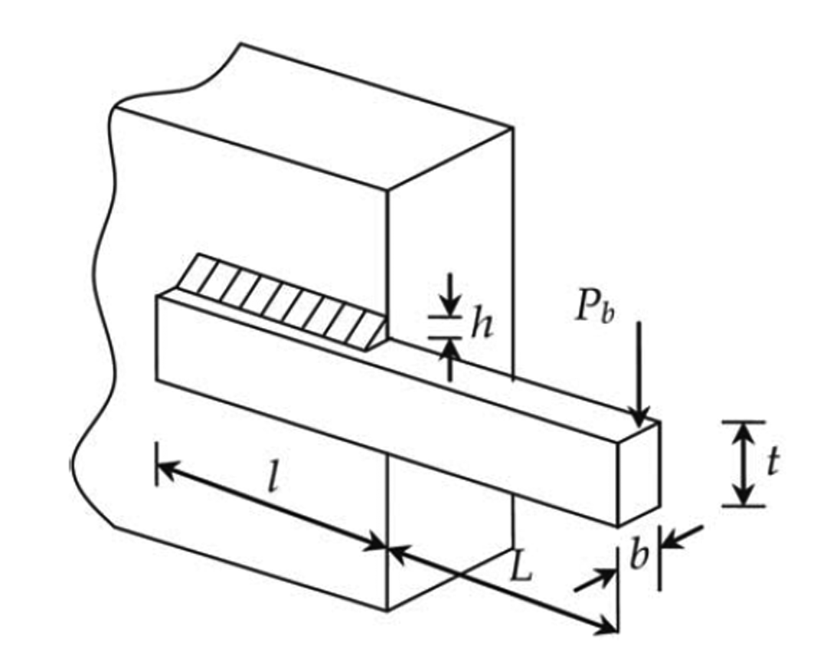
Figure 2.1. An example figure.

Tables
Tables which can fit in one full page including the caption may appear on the same page with the text. For longer tables occupying more than one full page, the table must be placed on a separate sheet. Tables should be inserted as near as possible to the text they illustrate. All tables must also be labeled, same as Figures, and consecutively through the thesis.
All tables must have captions and follow the same rules as figure captions, except Table caption is located above the table. A List of Tables should be given after the List of Figures. The table caption and label used in Table 2.1 can be copy/pasted and used for additional tables by changing the label number and caption text. The list of tables will be automatically updated. The text style used in the tables is Times New Times Roman (size 11). References should be specified to information taken from other resources.
Do not refer to tables within the text as “see below” or “see above”. Refer to all tables using their numbers. For example “As shown in Table 3.2 …”. Reference to tables should be included within the main text.

Equations
- Use equation editor of word processing packages for writing equations or alternatively download a software called “Math Type” use it for specifying equations.
- S.I. units must be used. If you are copying data from a reference, convert the units when necessary.
- All mathematical symbols within text must be in italic.
- All equations must be numbered based on chapter number and equation number and centered in the page. For example:
(2.1)
- Specify the equation number only between the parentheses.
- Do not refer to equations within the text as “see below” or “see above”. Refer to all equations using their numbers. For example “As shown in Equation 3.2 …”.
- All mathematical symbols used in the equation must be defined within the main text and specified in italics style.
Table 2.1. An example table.
Colums 1 | Colums 2 | Column 3
Row 1 [3] | 263.89584 | 120,000
Row 2 | 263.89584 | 5,250
Row 3 | 263.89718 | 3,150
Row 4 | 263.89584 | 2,650

Footnotes
Footnotes are not allowed.

Appendices
Appendices may be used to present detailed information whose inclusion within the text would unnecessarily obstruct clear presentation of the argument. An appendix should be labeled, and such appendix should be independent of others.
Appendices, if any, are placed at the very end of your thesis. You can include any detailed and lengthy information and data from your project that are not of interest to a normal reader but which might be useful for documentation. Number each appendix in the order as it is mentioned in the text, e.g. Appendix A, Appendix B, etc.
Appendix material may include: statistical tables; detailed results of experiments; series of graphs; summaries of results obtained elsewhere; detailed maps, charts and diagrams; pseudocodes; schematic diagrams; and program listings.

References
A list of references should be provided when the thesis contains information from other sources and should be cited based on the following Table as required by the Faculty/School/Programme Area.
Table: Referencing type (e.g. APA, MLA, Oxford, Harvard, IEEE etc. to be followed)
Faculty/School | Programme Area | Referencing
Faculty of Engineering | Civil Engineering | Harvard
 | Mechanical Engineering | IEEE citation style (or Vancouver system)
 | Electrical Engineering | IEEE citation style (or Vancouver system)
 | Petroleum and Chemical Engineering | IEEE citation style (or Vancouver system)
School of Business | Accounting | APA
 | Economics | APA
 | Management | APA
School of Computing and Informatics | Creative Computing (CC) | ​APA
 | Computer and Information Systems (CIS) | APA
 | Computer Network Security (CNS) | APA
School of Applied Sciences and Mathematics | Applied Mathematics and Economics | APA
 | Food Science and Technology | APA
School of Design | Architecture | APA
Centre for Communication, Teaching and Learning | Teaching and Learning | APA
 | Communication | APA
 | Melayu Islam Beraja | APA

Harvard (https://www.mendeley.com/guides/harvard-citation-guide)
IEEE (https://ieee-dataport.org/sites/default/files/analysis/27/IEEE%20Citation%20Guidelines.pdf)
APA (https://www.mendeley.com/guides/apa-citation-guide)
For Example, Literature references in the text should be cited by numerals on the line in square brackets following the IEEE Referencing Format (ME/EE/PCE).
Wherever possible, references should be specific and to the primary published source material, i.e. to a journal article or conference proceedings or to a book, and not to a web page containing reference to the primary source (web pages often have a limited lifetime. In addition, web material is not subject to any quality control in the form of peer review). The first reference (i.e. [1]) should be the first mentioned in the thesis as per IEEE citation style. This means, in general, references should be cited in sequential order as 1, 2, 3, etc. in the thesis. Following are the examples representing different types of citations under IEEE citation style.
Students can use the MS Word “Reference” tab and “Insert Citation” to create citations.
This template uses IEEE referencing style available in MS Word.
Journal Articles – Example [1]
Conference Articles – Example [2]
Books – Example [3]
Websites – [4]

Plagiarism
Plagiarism is the unacknowledged use of the words, ideas or creations of others and it is not allowed. Students should make use of Turnitin for the thesis text from the first chapter to the last chapter. A thesis should not have more than 20% similarities given by the Turnitin.

References
[1] | A. Sadollah, A. Bahreininejad, H. Eskandar and M. Hamdi, "Mine blast algorithm: a new population based algorithm for solving constrained engineering optimization problems," Applied Soft Computing, vol. 13, pp. 2592-2612, 2013.
[2] | J. Cai and G. Thierauf, "Discrete structural optimization using evolution strategies," in Neural Networks and Combinatorial Optimization in Civil and Structural Engineering, Cambridge, UK, 1994.
[3] | A. Bahreininejad and B.H.V. Topping, Neural Computing for Structural Mechanics, Civil-Comp, 1997.
[4] | "Arduino," Arduino, 2017. [Online]. Available: https://store.arduino.cc/usa/arduino-robot. [Accessed 2017].

