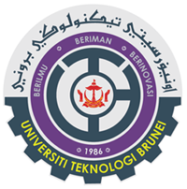
Universiti Teknologi Brunei
Alumni Form
*Please complete the form
Full Name
IC Number
Gender | Male / Female (please highlight/underline)
Date of Birth
Course & Intake | Example: HND in Computing, Intake 24
Contact Number | (H) | (M)
Current Occupation and Organisation
Professional / Other Qualifications
Please include the name of University / Institution, if any

Scan Me
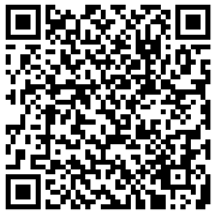
For more information, Please contact us at:
Alumni Affairs Unit
Universiti Teknologi Brunei
Jalan Tungku Link
Negara Brunei Darussalam
E-mail: alumni@utb.edu.bn | Tel: 2461020 ext 5360
Visit to our website: http://www.utb.edu.bn/industry-services/alumni-affairs-unit/

